
Remove this
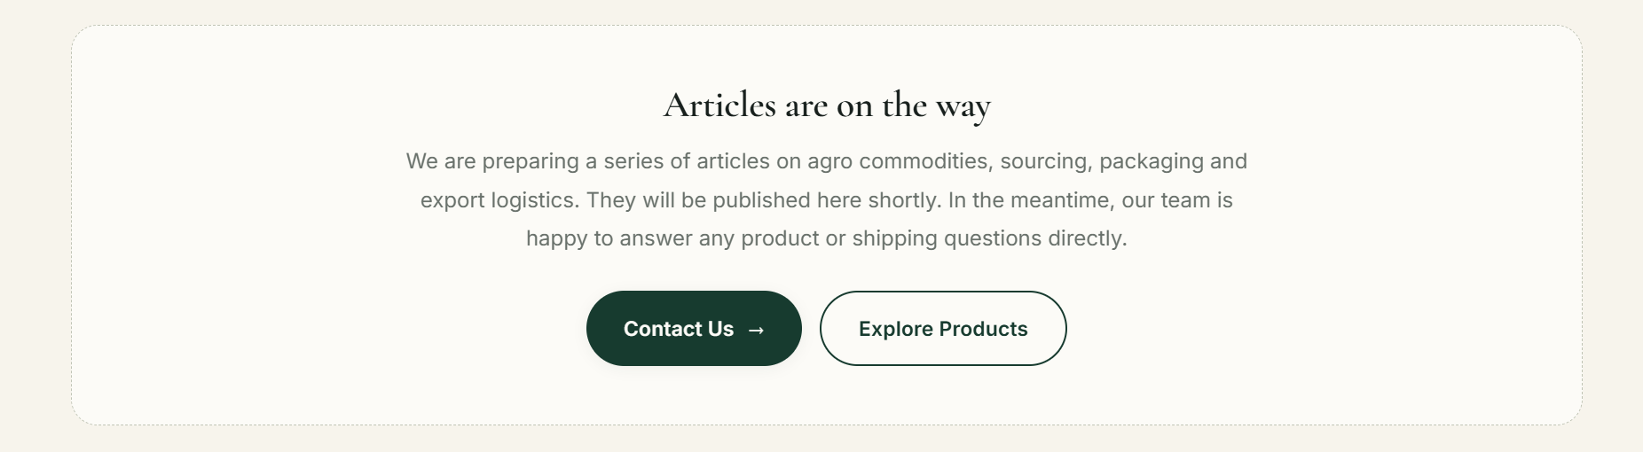
Remove this

Change ‘Please choose your topic below for detailed insight’
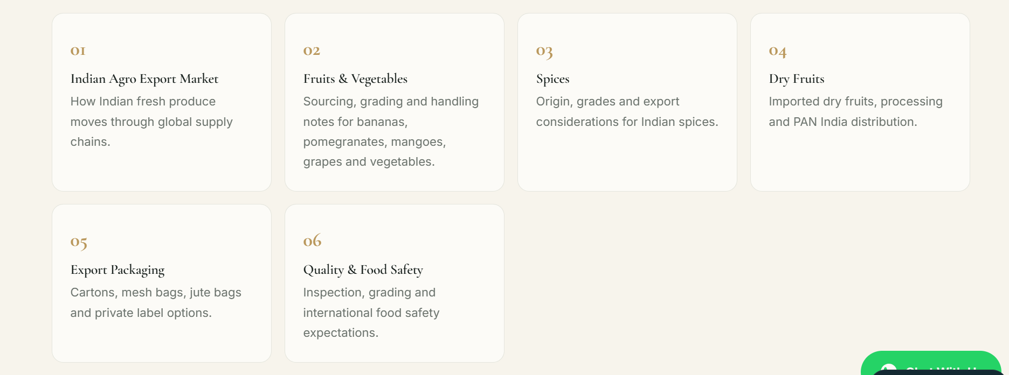
Add read more button in each topic redirecting to a new page where visitor can read entire article related to that particular topic.
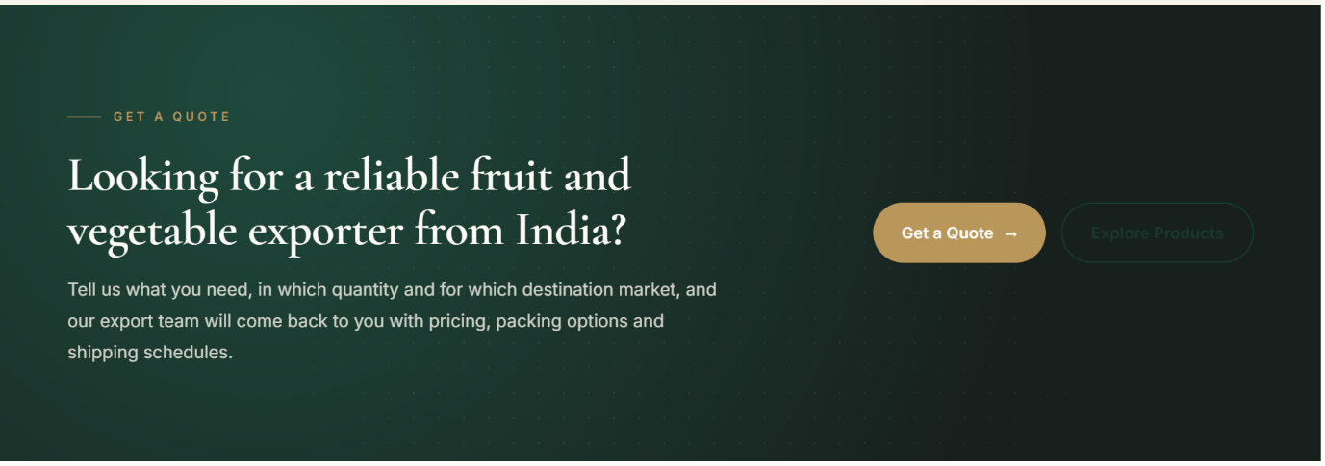
Copy this section and paste here.
Footer as it is.

